Assignment-4

Python Programming

|  |  |
| --- | --- |
| Assignment Date | 22 October 2022 |
| Student Name | Satheshpandi P |
| Student Roll Number | 921319205127 |
| Maximum Marks | 2 Marks |

In [1]:

**import** pandas **as** pd

**import** numpy **as** np

**import** matplotlib.pyplot **as** plt

**import** seaborn **as** sns

# Loading the dataset

In [ ]:

df **=** pd**.**read_csv('Mall_Customers.csv') df

|  |  |  |  |  |  |  |  |
| --- | --- | --- | --- | --- | --- | --- | --- |
| Out[ | ]: |  | **CustomerID** | **Gender** | **Age** | **Annual Income (k$)** | **Spending Score (1-100)** |
|  |  | **0** | 1 | Male | 19 | 15 | 39 |
|  |  | **1** | 2 | Male | 21 | 15 | 81 |
|  |  | **2** | 3 | Female | 20 | 16 | 6 |
|  |  | **3** | 4 | Female | 23 | 16 | 77 |
|  |  | **4** | 5 | Female | 31 | 17 | 40 |
|  |  | **...** | ... | ... | ... | ... | ... |
|  |  | **195** | 196 | Female | 35 | 120 | 79 |
|  |  | **196** | 197 | Female | 45 | 126 | 28 |
|  |  | **197** | 198 | Male | 32 | 126 | 74 |
|  |  | **198** | 199 | Male | 32 | 137 | 18 |
|  |  | **199** | 200 | Male | 30 | 137 | 83 |

200 rows × 5 columns

# Encoding Categorical Columns

In [ ]:

**from** sklearn.preprocessing **import** LabelEncoder le **=** LabelEncoder()

df['Gender'] **=** le**.**fit_transform(df['Gender'])

|  |  |  |  |  |  |  |  |
| --- | --- | --- | --- | --- | --- | --- | --- |
| In [ | ]: | df |  | | | | |
| Out[ | ]: |  | **CustomerID** | **Gender** | **Age** | **Annual Income (k$)** | **Spending Score (1-100)** |
|  |  | **0** | 1 | 1 | 19 | 15 | 39 |
|  |  | **1** | 2 | 1 | 21 | 15 | 81 |
|  |  | **2** | 3 | 0 | 20 | 16 | 6 |

|  |  |  |  |  |  |
| --- | --- | --- | --- | --- | --- |
| **3** | 4 | 0 | 23 | 16 | 77 |
| **4** | 5 | 0 | 31 | 17 | 40 |
| **...** | ... | ... | ... | ... | ... |
| **195** | 196 | 0 | 35 | 120 | 79 |
| **196** | 197 | 0 | 45 | 126 | 28 |
| **197** | 198 | 1 | 32 | 126 | 74 |
| **198** | 199 | 1 | 32 | 137 | 18 |
| **199** | 200 | 1 | 30 | 137 | 83 |

200 rows × 5 columns

# Visualizations Univariate Analysis

plt**.**hist(df['Age'])

In [ ]:

Out[ ]:

In [ ]:

(array([31., 19., 34., 29., 16., 26., 15., 10., 6., 14.]),

array([18. , 23.2, 28.4, 33.6, 38.8, 44. , 49.2, 54.4, 59.6, 64.8, 70. ]),

<a list of 10 Patch objects>)

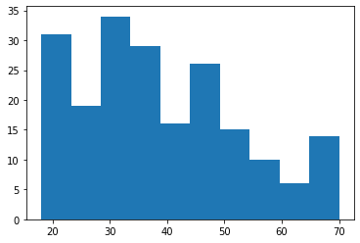

Out[ ]:

(array([24., 22., 28., 38., 30., 36., 8., 6., 4., 4.]),

plt**.**hist(df['Annual Income (k$)'])

array([ 15. , 27.2, 39.4, 51.6, 63.8, 76. , 88.2, 100.4, 112.6,

124.8, 137. ]),

<a list of 10 Patch objects>)

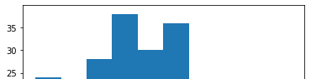

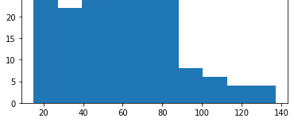

In [ ]:

plt**.**hist(df['Spending Score (1-100)'])

Out[ ]:

|  |  |  |
| --- | --- | --- |
| (array([16., 20., 10., 17., 35., 37., | 11., 24., 14., 16.]), |  |
| array([ 1. , 10.8, 20.6, 30.4, 40.2, | 50. , 59.8, 69.6, 79.4, | 89.2, 99. ]), |
| <a list of 10 Patch objects>) |  |  |

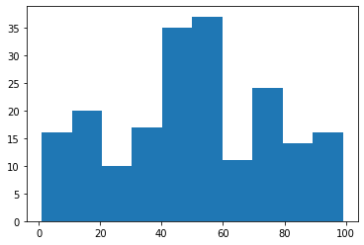

In [ ]:

sns**.**countplot(df['Gender'])

Out[ ]:

/usr/local/lib/python3.7/dist-packages/seaborn/_decorators.py:43: FutureWarnin g: Pass the following variable as a keyword arg: x. From version 0.12, the only valid positional argument will be `data`, and passing other arguments without a n explicit keyword will result in an error or misinterpretation.

FutureWarning

<matplotlib.axes._subplots.AxesSubplot at 0x7fdb93a2d490>

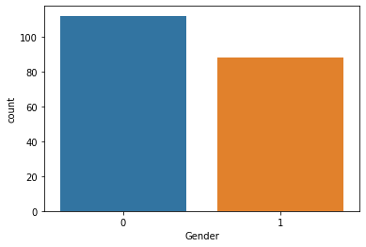

# Bi-Variate Analysis

In [ ]:

sns**.**scatterplot(df['Annual Income (k$)'], df['Spending Score (1-100)'])

Out[ ]:

In [ ]:

sns**.**barplot(df['Gender'], df['Age'])

/usr/local/lib/python3.7/dist-packages/seaborn/_decorators.py:43: FutureWarnin g: Pass the following variables as keyword args: x, y. From version 0.12, the o nly valid positional argument will be `data`, and passing other arguments witho ut an explicit keyword will result in an error or misinterpretation.

FutureWarning

<matplotlib.axes._subplots.AxesSubplot at 0x7fdb93a1f1d0>

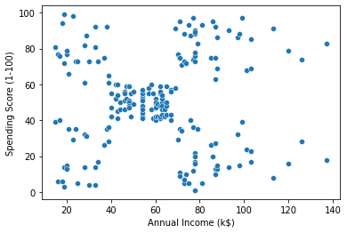

Out[ ]:

In [ ]:

sns**.**heatmap(df**.**corr(), annot **= True**)

/usr/local/lib/python3.7/dist-packages/seaborn/_decorators.py:43: FutureWarnin g: Pass the following variables as keyword args: x, y. From version 0.12, the o nly valid positional argument will be `data`, and passing other arguments witho ut an explicit keyword will result in an error or misinterpretation.

FutureWarning

<matplotlib.axes._subplots.AxesSubplot at 0x7fdb93931b90>

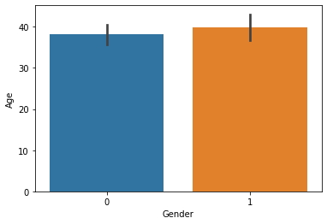

Out[ ]:

In [ ]:

sns**.**pairplot(df)

<matplotlib.axes._subplots.AxesSubplot at 0x7fdb9390e4d0>

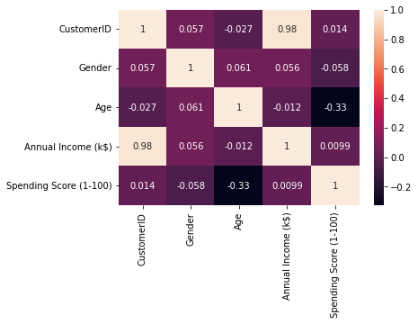

# Multi-variate Analysis

Out[ ]:

<seaborn.axisgrid.PairGrid at 0x7fdb91011e50>

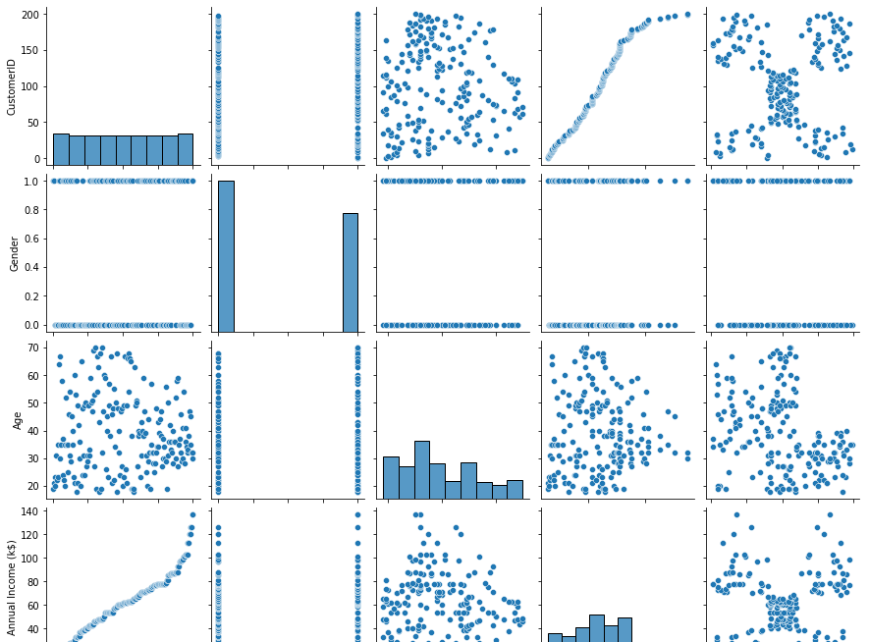

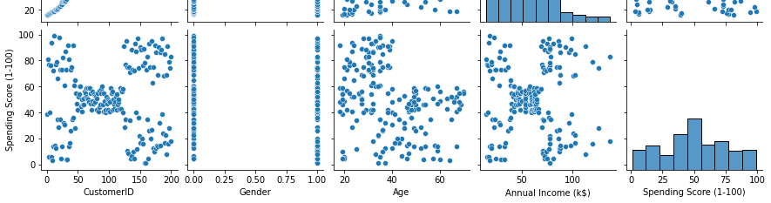

In [ ]:

# Descriptive Statistics

In [ ]:

df**.**info()

<class 'pandas.core.frame.DataFrame'> RangeIndex: 200 entries, 0 to 199

Data columns (total 5 columns):

# Column Non-Null Count Dtype

|  |  |  |  |  |  |  |  |
| --- | --- | --- | --- | --- | --- | --- | --- |
| 0 |  | CustomerID |  | 200 | non-null |  | int64 |
| 1 |  | Gender |  | 200 | non-null |  | int64 |
| 2 |  | Age |  | 200 | non-null |  | int64 |
| 3 |  | Annual Income | (k$) | 200 | non-null |  | int64 |
| 4 | Spending Score (1-100) | | | 200 | non-null | int64 | |

dtypes: int64(5)

memory usage: 7.9 KB

|  |  |  |  |  |  |  |  |  |
| --- | --- | --- | --- | --- | --- | --- | --- | --- |
| In | [ | ]: | df**.**describe() | | | | | |
| Out[ | | ]: |  | **CustomerID** | **Gender** | **Age** | **Annual Income (k$)** | **Spending Score (1-100)** |
|  | |  | **count** | 200.000000 | 200.000000 | 200.000000 | 200.000000 | 200.000000 |
|  | |  | **mean** | 100.500000 | 0.440000 | 38.850000 | 60.560000 | 50.200000 |
|  | |  | **std** | 57.879185 | 0.497633 | 13.969007 | 26.264721 | 25.823522 |
|  | |  | **min** | 1.000000 | 0.000000 | 18.000000 | 15.000000 | 1.000000 |
|  | |  | **25%** | 50.750000 | 0.000000 | 28.750000 | 41.500000 | 34.750000 |
|  | |  | **50%** | 100.500000 | 0.000000 | 36.000000 | 61.500000 | 50.000000 |
|  | |  | **75%** | 150.250000 | 1.000000 | 49.000000 | 78.000000 | 73.000000 |
|  | |  | **max** | 200.000000 | 1.000000 | 70.000000 | 137.000000 | 99.000000 |
| In [ | | ]: | df**.**skew() | | | | | |

Out[ ]:

|  |  |  |
| --- | --- | --- |
| CustomerID |  | 0.000000 |
| Gender |  | 0.243578 |
| Age |  | 0.485569 |
| Annual Income | (k$) | 0.321843 |

Spending Score (1-100) -0.047220 dtype: float64

In [ ]:

df**.**kurt()

Out[ ]:

In [ ]:

df**.**corr()

|  |  |  |
| --- | --- | --- |
| CustomerID |  | -1.200000 |
| Gender |  | -1.960375 |
| Age |  | -0.671573 |
| Annual Income | (k$) | -0.098487 |

Spending Score (1-100) -0.826629 dtype: float64

Out[ ]:

**CustomerID Gender Age Annual Income**

**Spending Score**

|  |  |  |  |  |  |
| --- | --- | --- | --- | --- | --- |
|  | | | | **(k$)** | **(1-100)** |
| **CustomerID** | 1.000000 | 0.057400 | -0.026763 | 0.977548 | 0.013835 |
| **Gender** | 0.057400 | 1.000000 | 0.060867 | 0.056410 | -0.058109 |
| **Age** | -0.026763 | 0.060867 | 1.000000 | -0.012398 | -0.327227 |
| **Annual Income (k$)** | 0.977548 | 0.056410 | -0.012398 | 1.000000 | 0.009903 |

**Spending Score (1-**

**100)**

0.013835 -0.058109 -0.327227 0.009903 1.000000

In [ ]:

df**.**var()

Out[ ]:

In [ ]:

Out[ ]:

In [ ]:

df**.**isna()**.**sum()

CustomerID 3350.000000

Gender 0.247638

Age 195.133166

Annual Income (k$) 689.835578

|  |  |  |
| --- | --- | --- |
| Spending Score  dtype: float64 | (1-100) | 666.854271 |
| df**.**std() |  |  |
| CustomerID |  | 57.879185 |
| Gender | | 0.497633 |
| Age | | 13.969007 |
| Annual Income (k$) | | 26.264721 |
| Spending Score (1-100)  dtype: float64 | | 25.823522 |

# Checking for missing values

Out[ ]:

|  |  |  |
| --- | --- | --- |
| CustomerID |  | 0 |
| Gender |  | 0 |
| Age |  | 0 |
| Annual Income | (k$) | 0 |

Spending Score (1-100) 0

dtype: int64

In [ ]:

df**.**isna()**.**sum()**.**sum()

Out[ ]: 0

In [ ]:

df**.**duplicated()**.**sum()

Out[ ]:

In [ ]:

quantile **=** df**.**quantile(q **=** [0.25, 0.75]) quantile

0

# Finding & Handling Ouliers

Out[ ]:

In [ ]:

IQR **=** quantile**.**iloc[1] **-** quantile**.**iloc[0] IQR

**CustomerID Gender Age Annual Income (k$) Spending Score (1-100) 0.25** 50.75 0.0 28.75 41.5 34.75

**0.75** 150.25 1.0 49.00 78.0 73.00

Out[ ]:

In [ ]:

CustomerID 99.50

Gender 1.00

Age 20.25

Annual Income (k$) 36.50

Spending Score (1-100) 38.25

dtype: float64

upper **=** quantile**.**iloc[1] **+** (1.5 **\***IQR) upper

Out[ ]:

In [ ]:

CustomerID 299.500

Gender 2.500

Age 79.375

Annual Income (k$) 132.750

Spending Score (1-100) 130.375

dtype: float64

lower **=** quantile**.**iloc[0] **-** (1.5**\*** IQR) lower

Out[ ]:

CustomerID -98.500

Gender -1.500

Age -1.625

Annual Income (k$) -13.250 Spending Score (1-100) -22.625 dtype: float64

In [ ]:

df**.**mean()

Out[ ]:

In [ ]:

CustomerID 100.50

Gender 0.44

Age 38.85

Annual Income (k$) 60.56

Spending Score (1-100) 50.20

dtype: float64

df['Annual Income (k$)']**.**max()

Out[ ]:

In [ ]:

137

Out[ ]:

In [ ]:

sns**.**boxplot(df['Gender'])

/usr/local/lib/python3.7/dist-packages/seaborn/_decorators.py:43: FutureWarnin g: Pass the following variable as a keyword arg: x. From version 0.12, the only valid positional argument will be `data`, and passing other arguments without a n explicit keyword will result in an error or misinterpretation.

sns**.**boxplot(df['CustomerID'])

FutureWarning

<matplotlib.axes._subplots.AxesSubplot at 0x7fdb904c1290>

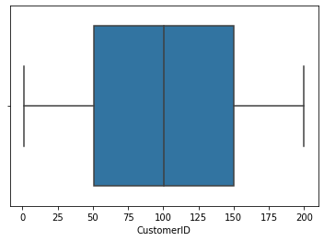

Out[ ]:

/usr/local/lib/python3.7/dist-packages/seaborn/_decorators.py:43: FutureWarnin g: Pass the following variable as a keyword arg: x. From version 0.12, the only valid positional argument will be `data`, and passing other arguments without a n explicit keyword will result in an error or misinterpretation.

FutureWarning

<matplotlib.axes._subplots.AxesSubplot at 0x7fdb8ebea250>



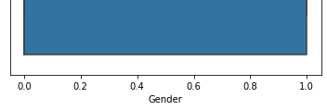

In [ ]:

sns**.**boxplot(df['Age'])

Out[ ]:

In [ ]:

sns**.**boxplot(df['Annual Income (k$)'])

/usr/local/lib/python3.7/dist-packages/seaborn/_decorators.py:43: FutureWarnin g: Pass the following variable as a keyword arg: x. From version 0.12, the only valid positional argument will be `data`, and passing other arguments without a n explicit keyword will result in an error or misinterpretation.

FutureWarning

<matplotlib.axes._subplots.AxesSubplot at 0x7fdb93b3ee50>

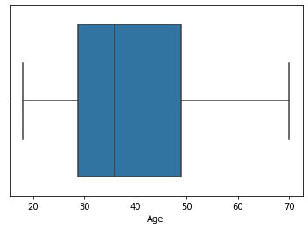

Out[ ]:

/usr/local/lib/python3.7/dist-packages/seaborn/_decorators.py:43: FutureWarnin g: Pass the following variable as a keyword arg: x. From version 0.12, the only valid positional argument will be `data`, and passing other arguments without a n explicit keyword will result in an error or misinterpretation.

FutureWarning

<matplotlib.axes._subplots.AxesSubplot at 0x7fdb8eb28450>

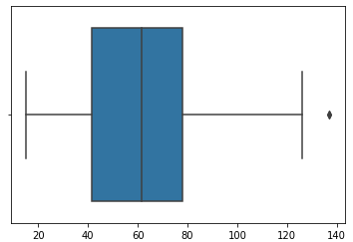



In [ ]:

df['Annual Income (k$)'] **=** np**.**where(df['Annual Income (k$)'] **>** 132.750, 60.55,

In [ ]:

sns**.**boxplot(df['Annual Income (k$)'])

Out[ ]:

In [ ]:

df['Annual Income (k$)']**.**max()

/usr/local/lib/python3.7/dist-packages/seaborn/_decorators.py:43: FutureWarnin g: Pass the following variable as a keyword arg: x. From version 0.12, the only valid positional argument will be `data`, and passing other arguments without a n explicit keyword will result in an error or misinterpretation.

FutureWarning

<matplotlib.axes._subplots.AxesSubplot at 0x7fdb8eb18e90>

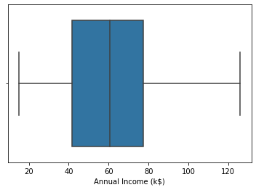

Out[ ]:

In [ ]:

126.0

Out[ ]:

/usr/local/lib/python3.7/dist-packages/seaborn/_decorators.py:43: FutureWarnin g: Pass the following variable as a keyword arg: x. From version 0.12, the only valid positional argument will be `data`, and passing other arguments without a n explicit keyword will result in an error or misinterpretation.

sns**.**boxplot(df['Spending Score (1-100)'])

FutureWarning

<matplotlib.axes._subplots.AxesSubplot at 0x7fdb8ea8fc10>

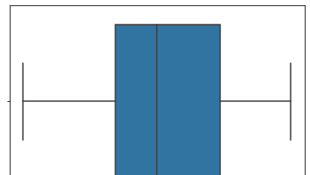

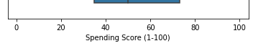

# Scaling the data

In [ ]:

**from** sklearn.preprocessing **import** StandardScaler ss **=** StandardScaler()**.**fit_transform(df)

ss

Out[ ]:

|  |  |  |  |  |
| --- | --- | --- | --- | --- |
| array([[-1.7234121 , | 1.12815215, | -1.42456879, | -1.78843062, | -0.43480148], |
| [-1.70609137, | 1.12815215, | -1.28103541, | -1.78843062, | 1.19570407], |
| [-1.68877065, | -0.88640526, | -1.3528021 , | -1.74850629, | -1.71591298], |
| [-1.67144992, | -0.88640526, | -1.13750203, | -1.74850629, | 1.04041783], |
| [-1.6541292 , | -0.88640526, | -0.56336851, | -1.70858195, | -0.39597992], |
| [-1.63680847, | -0.88640526, | -1.20926872, | -1.70858195, | 1.00159627], |
| [-1.61948775, | -0.88640526, | -0.27630176, | -1.66865761, | -1.71591298], |
| [-1.60216702, | -0.88640526, | -1.13750203, | -1.66865761, | 1.70038436], |
| [-1.5848463 , | 1.12815215, | 1.80493225, | -1.62873328, | -1.83237767], |
| [-1.56752558, | -0.88640526, | -0.6351352 , | -1.62873328, | 0.84631002], |
| [-1.55020485, | 1.12815215, | 2.02023231, | -1.62873328, | -1.4053405 ], |
| [-1.53288413, | -0.88640526, | -0.27630176, | -1.62873328, | 1.89449216], |
| [-1.5155634 , | -0.88640526, | 1.37433211, | -1.58880894, | -1.36651894], |
| [-1.49824268, | -0.88640526, | -1.06573534, | -1.58880894, | 1.04041783], |
| [-1.48092195, | 1.12815215, | -0.13276838, | -1.58880894, | -1.44416206], |
| [-1.46360123, | 1.12815215, | -1.20926872, | -1.58880894, | 1.11806095], |
| [-1.4462805 , | -0.88640526, | -0.27630176, | -1.5488846 , | -0.59008772], |
| [-1.42895978, | 1.12815215, | -1.3528021 , | -1.5488846 , | 0.61338066], |
| [-1.41163905, | 1.12815215, | 0.94373197, | -1.46903593, | -0.82301709], |
| [-1.39431833, | -0.88640526, | -0.27630176, | -1.46903593, | 1.8556706 ], |
| [-1.3769976 , | 1.12815215, | -0.27630176, | -1.42911159, | -0.59008772], |
| [-1.35967688, | 1.12815215, | -0.99396865, | -1.42911159, | 0.88513158], |
| [-1.34235616, | -0.88640526, | 0.51313183, | -1.38918726, | -1.75473454], |
| [-1.32503543, | 1.12815215, | -0.56336851, | -1.38918726, | 0.88513158], |
| [-1.30771471, | -0.88640526, | 1.08726535, | -1.26941425, | -1.4053405 ], |
| [-1.29039398, | 1.12815215, | -0.70690189, | -1.26941425, | 1.23452563], |
| [-1.27307326, | -0.88640526, | 0.44136514, | -1.26941425, | -0.7065524 ], |
| [-1.25575253, | 1.12815215, | -0.27630176, | -1.26941425, | 0.41927286], |
| [-1.23843181, | -0.88640526, | 0.08253169, | -1.22948991, | -0.74537397], |
| [-1.22111108, | -0.88640526, | -1.13750203, | -1.22948991, | 1.42863343], |
| [-1.20379036, | 1.12815215, | 1.51786549, | -1.18956557, | -1.7935561 ], |
| [-1.18646963, | -0.88640526, | -1.28103541, | -1.18956557, | 0.88513158], |
| [-1.16914891, | 1.12815215, | 1.01549866, | -1.06979256, | -1.7935561 ], |
| [-1.15182818, | 1.12815215, | -1.49633548, | -1.06979256, | 1.62274124], |
| [-1.13450746, | -0.88640526, | 0.7284319 , | -1.06979256, | -1.4053405 ], |
| [-1.11718674, | -0.88640526, | -1.28103541, | -1.06979256, | 1.19570407], |
| [-1.09986601, | -0.88640526, | 0.22606507, | -1.02986823, | -1.28887582], |
| [-1.08254529, | -0.88640526, | -0.6351352 , | -1.02986823, | 0.88513158], |
| [-1.06522456, | -0.88640526, | -0.20453507, | -0.91009522, | -0.93948177], |
| [-1.04790384, | -0.88640526, | -1.3528021 , | -0.91009522, | 0.96277471], |
| [-1.03058311, | -0.88640526, | 1.87669894, | -0.87017088, | -0.59008772], |
| [-1.01326239, | 1.12815215, | -1.06573534, | -0.87017088, | 1.62274124], |
| [-0.99594166, | 1.12815215, | 0.65666521, | -0.83024654, | -0.55126616], |
| [-0.97862094, | -0.88640526, | -0.56336851, | -0.83024654, | 0.41927286], |
| [-0.96130021, | -0.88640526, | 0.7284319 , | -0.83024654, | -0.86183865], |
| [-0.94397949, | -0.88640526, | -1.06573534, | -0.83024654, | 0.5745591 ], |

|  |  |  |  |  |  |  |
| --- | --- | --- | --- | --- | --- | --- |
| [-0.92665877, | | -0.88640526, | 0.80019859, | -0.79032221, | | 0.18634349], |
| [-0.90933804, | | -0.88640526, | -0.85043527, | -0.79032221, | | -0.12422899], |
| [-0.89201732, | | -0.88640526, | -0.70690189, | -0.79032221, | | -0.3183368 ], |
| [-0.87469659, | | -0.88640526, | -0.56336851, | -0.79032221, | | -0.3183368 ], |
| [-0.85737587, | | -0.88640526, | 0.7284319 , | -0.71047353, | | 0.06987881], |
| [-0.84005514, | | 1.12815215, | -0.41983513, | -0.71047353, | | 0.38045129], |
| [-0.82273442, | | -0.88640526, | -0.56336851, | -0.6705492 | , | 0.14752193], |
| [-0.80541369, | | 1.12815215, | 1.4460988 , | -0.6705492 | , | 0.38045129], |
| [-0.78809297, | | -0.88640526, | 0.80019859, | -0.6705492 | , | -0.20187212], |
| [-0.77077224, | | 1.12815215, | 0.58489852, | -0.6705492 | , | -0.35715836], |
| [-0.75345152, | | -0.88640526, | 0.87196528, | -0.63062486, | | -0.00776431], |
| [-0.73613079, | | 1.12815215, | 2.16376569, | -0.63062486, | | -0.16305055], |
| [-0.71881007, | | -0.88640526, | -0.85043527, | -0.55077619, | | 0.03105725], |
| [-0.70148935, | | 1.12815215, | 1.01549866, | -0.55077619, | | -0.16305055], |
| [-0.68416862, | | 1.12815215, | 2.23553238, | -0.55077619, | | 0.22516505], |
| [-0.6668479 , | | 1.12815215, | -1.42456879, | -0.55077619, | | 0.18634349], |
| [-0.64952717, | | -0.88640526, | 2.02023231, | -0.51085185, | | 0.06987881], |
| [-0.63220645, | | -0.88640526, | 1.08726535, | -0.51085185, | | 0.34162973], |
| [-0.61488572, | | 1.12815215, | 1.73316556, | -0.47092751, | | 0.03105725], |
| [-0.597565 , | | 1.12815215, | -1.49633548, | -0.47092751, | | 0.34162973], |
| [-0.58024427, | | -0.88640526, | 0.29783176, | -0.47092751, | | -0.00776431], |
| [-0.56292355, | | -0.88640526, | 2.091999 , | -0.47092751, | | -0.08540743], |
| [-0.54560282, | | 1.12815215, | -1.42456879, | -0.47092751, | | 0.34162973], |
| [-0.5282821 , | | -0.88640526, | -0.49160182, | -0.47092751, | | -0.12422899], |
| [-0.51096138, | | 1.12815215, | 2.23553238, | -0.43100318, | | 0.18634349], |
| [-0.49364065, | | -0.88640526, | 0.58489852, | -0.43100318, | | -0.3183368 ], |
| [-0.47631993, | | -0.88640526, | 1.51786549, | -0.39107884, | | -0.04658587], |
| [-0.4589992 , | | -0.88640526, | 1.51786549, | -0.39107884, | | 0.22516505], |
| [-0.44167848, | | 1.12815215, | 1.4460988 , | -0.23138149, | | -0.12422899], |
| [-0.42435775, | | 1.12815215, | -0.92220196, | -0.23138149, | | 0.14752193], |
| [-0.40703703, | | -0.88640526, | 0.44136514, | -0.23138149, | | 0.10870037], |
| [-0.3897163 , | | 1.12815215, | 0.08253169, | -0.23138149, | | -0.08540743], |
| [-0.37239558, | | -0.88640526, | -1.13750203, | -0.23138149, | | 0.06987881], |
| [-0.35507485, | | -0.88640526, | 0.7284319 , | -0.23138149, | | -0.3183368 ], |
| [-0.33775413, | | 1.12815215, | 1.30256542, | -0.23138149, | | 0.03105725], |
| [-0.3204334 , | | 1.12815215, | -0.06100169, | -0.23138149, | | 0.18634349], |
| [-0.30311268, | | 1.12815215, | 2.02023231, | -0.23138149, | | -0.35715836], |
| [-0.28579196, | | -0.88640526, | 0.51313183, | -0.23138149, | | -0.24069368], |
| [-0.26847123, | | -0.88640526, | -1.28103541, | -0.23138149, | | 0.26398661], |
| [-0.25115051, | | 1.12815215, | 0.65666521, | -0.23138149, | | -0.16305055], |
| [-0.23382978, | | -0.88640526, | 1.15903204, | -0.11160848, | | 0.30280817], |
| [-0.21650906, | | -0.88640526, | -1.20926872, | -0.11160848, | | 0.18634349], |
| [-0.19918833, | | -0.88640526, | -0.34806844, | -0.07168415, | | 0.38045129], |
| [-0.18186761, | | -0.88640526, | 0.80019859, | -0.07168415, | | -0.16305055], |
| [-0.16454688, | | -0.88640526, | 2.091999 , | -0.03175981, | | 0.18634349], |
| [-0.14722616, | | 1.12815215, | -1.49633548, | -0.03175981, | | -0.35715836], |
| [-0.12990543, | | 1.12815215, | 0.65666521, | 0.00816453, | | -0.04658587], |
| [-0.11258471, | | -0.88640526, | 0.08253169, | 0.00816453, | | -0.39597992], |
| [-0.09526399, | | -0.88640526, | -0.49160182, | 0.00816453, | | -0.3183368 ], |
| [-0.07794326, | | 1.12815215, | -1.06573534, | 0.00816453, | | 0.06987881], |
| [-0.06062254, | | -0.88640526, | 0.58489852, | 0.00816453, | | -0.12422899], |
| [-0.04330181, | | -0.88640526, | -0.85043527, | 0.00816453, | | -0.00776431], |
| [-0.02598109, | | 1.12815215, | 0.65666521, | 0.04808886, | | -0.3183368 ], |
| [-0.00866036, | | 1.12815215, | -1.3528021 , | 0.04808886, | | -0.04658587], |
| [ | 0.00866036, | -0.88640526, | -1.13750203, | 0.0880132 | , | -0.35715836], |
| [ | 0.02598109, | -0.88640526, | 0.7284319 , | 0.0880132 | , | -0.08540743], |
| [ | 0.04330181, | 1.12815215, | 2.02023231, | 0.0880132 | , | 0.34162973], |
| [ | 0.06062254, | 1.12815215, | -0.92220196, | 0.0880132 | , | 0.18634349], |
| [ | 0.07794326, | 1.12815215, | 0.7284319 , | 0.0880132 | , | 0.22516505], |
| [ | 0.09526399, | -0.88640526, | -1.28103541, | 0.0880132 | , | -0.3183368 ], |
| [ | 0.11258471, | -0.88640526, | 1.94846562, | 0.12793754, | | -0.00776431], |

|  |  |  |  |  |  |  |
| --- | --- | --- | --- | --- | --- | --- |
| [ | 0.12990543, | 1.12815215, | 1.08726535, | 0.12793754, | | -0.16305055], |
| [ | 0.14722616, | 1.12815215, | 2.091999 , | 0.12793754, | | -0.27951524], |
| [ | 0.16454688, | 1.12815215, | 1.94846562, | 0.12793754, | | -0.08540743], |
| [ | 0.18186761, | 1.12815215, | 1.87669894, | 0.12793754, | | 0.06987881], |
| [ | 0.19918833, | -0.88640526, | -1.42456879, | 0.12793754, | | 0.14752193], |
| [ | 0.21650906, | -0.88640526, | -0.06100169, | 0.16786187, | | -0.3183368 ], |
| [ | 0.23382978, | 1.12815215, | -1.42456879, | 0.16786187, | | -0.16305055], |
| [ | 0.25115051, | -0.88640526, | -1.49633548, | 0.20778621, | | -0.08540743], |
| [ | 0.26847123, | -0.88640526, | -1.42456879, | 0.20778621, | | -0.00776431], |
| [ | 0.28579196, | -0.88640526, | 1.73316556, | 0.20778621, | | -0.27951524], |
| [ | 0.30311268, | -0.88640526, | 0.7284319 , | 0.20778621, | | 0.34162973], |
| [ | 0.3204334 , | -0.88640526, | 0.87196528, | 0.28763488, | | -0.27951524], |
| [ | 0.33775413, | -0.88640526, | 0.80019859, | 0.28763488, | | 0.26398661], |
| [ | 0.35507485, | 1.12815215, | -0.85043527, | 0.28763488, | | 0.22516505], |
| [ | 0.37239558, | -0.88640526, | -0.06100169, | 0.28763488, | | -0.39597992], |
| [ | 0.3897163 , | -0.88640526, | 0.08253169, | 0.36748356, | | 0.30280817], |
| [ | 0.40703703, | 1.12815215, | 0.010765 , | 0.36748356, | | 1.58391968], |
| [ | 0.42435775, | -0.88640526, | -1.13750203, | 0.40740789, | | -0.82301709], |
| [ | 0.44167848, | -0.88640526, | -0.56336851, | 0.40740789, | | 1.04041783], |
| [ | 0.4589992 , | 1.12815215, | 0.29783176, | 0.44733223, | | -0.59008772], |
| [ | 0.47631993, | 1.12815215, | 0.08253169, | 0.44733223, | | 1.73920592], |
| [ | 0.49364065, | 1.12815215, | 1.4460988 , | 0.44733223, | | -1.52180518], |
| [ | 0.51096138, | 1.12815215, | -0.06100169, | 0.44733223, | | 0.96277471], |
| [ | 0.5282821 , | 1.12815215, | 0.58489852, | 0.44733223, | | -1.5994483 ], |
| [ | 0.54560282, | 1.12815215, | 0.010765 , | 0.44733223, | | 0.96277471], |
| [ | 0.56292355, | -0.88640526, | -0.99396865, | 0.48725657, | | -0.62890928], |
| [ | 0.58024427, | -0.88640526, | -0.56336851, | 0.48725657, | | 0.80748846], |
| [ | 0.597565 , | 1.12815215, | -1.3528021 , | 0.5271809 | , | -1.75473454], |
| [ | 0.61488572, | -0.88640526, | -0.70690189, | 0.5271809 | , | 1.46745499], |
| [ | 0.63220645, | -0.88640526, | 0.36959845, | 0.5271809 | , | -1.67709142], |
| [ | 0.64952717, | 1.12815215, | -0.49160182, | 0.5271809 | , | 0.88513158], |
| [ | 0.6668479 , | 1.12815215, | -1.42456879, | 0.56710524, | | -1.56062674], |
| [ | 0.68416862, | -0.88640526, | -0.27630176, | 0.56710524, | | 0.84631002], |
| [ | 0.70148935, | -0.88640526, | 1.30256542, | 0.60702958, | | -1.75473454], |
| [ | 0.71881007, | 1.12815215, | -0.49160182, | 0.60702958, | | 1.6615628 ], |
| [ | 0.73613079, | -0.88640526, | -0.77866858, | 0.64695391, | | -0.39597992], |
| [ | 0.75345152, | -0.88640526, | -0.49160182, | 0.64695391, | | 1.42863343], |
| [ | 0.77077224, | 1.12815215, | -0.99396865, | 0.68687825, | | -1.48298362], |
| [ | 0.78809297, | 1.12815215, | -0.77866858, | 0.68687825, | | 1.81684904], |
| [ | 0.80541369, | 1.12815215, | 0.65666521, | 0.68687825, | | -0.55126616], |
| [ | 0.82273442, | -0.88640526, | -0.49160182, | 0.68687825, | | 0.92395314], |
| [ | 0.84005514, | -0.88640526, | -0.34806844, | 0.72680259, | | -1.09476801], |
| [ | 0.85737587, | 1.12815215, | -0.34806844, | 0.72680259, | | 1.54509812], |
| [ | 0.87469659, | 1.12815215, | 0.29783176, | 0.72680259, | | -1.28887582], |
| [ | 0.89201732, | 1.12815215, | 0.010765 , | 0.72680259, | | 1.46745499], |
| [ | 0.90933804, | -0.88640526, | 0.36959845, | 0.72680259, | | -1.17241113], |
| [ | 0.92665877, | -0.88640526, | -0.06100169, | 0.72680259, | | 1.00159627], |
| [ | 0.94397949, | -0.88640526, | 0.58489852, | 0.72680259, | | -1.32769738], |
| [ | 0.96130021, | -0.88640526, | -0.85043527, | 0.72680259, | | 1.50627656], |
| [ | 0.97862094, | 1.12815215, | -0.13276838, | 0.72680259, | | -1.91002079], |
| [ | 0.99594166, | -0.88640526, | -0.6351352 , | 0.72680259, | | 1.07923939], |
| [ | 1.01326239, | 1.12815215, | -0.34806844, | 0.72680259, | | -1.91002079], |
| [ | 1.03058311, | -0.88640526, | -0.6351352 , | 0.72680259, | | 0.88513158], |
| [ | 1.04790384, | -0.88640526, | 1.23079873, | 0.76672692, | | -0.59008772], |
| [ | 1.06522456, | -0.88640526, | -0.70690189, | 0.76672692, | | 1.27334719], |
| [ | 1.08254529, | 1.12815215, | -1.42456879, | 0.8465756 , | | -1.75473454], |
| [ | 1.09986601, | -0.88640526, | -0.56336851, | 0.8465756 , | | 1.6615628 ], |
| [ | 1.11718674, | 1.12815215, | 0.80019859, | 1.00627294, | | -0.93948177], |
| [ | 1.13450746, | -0.88640526, | -0.20453507, | 1.00627294, | | 0.96277471], |
| [ | 1.15182818, | 1.12815215, | 0.22606507, | 1.04619728, | | -1.17241113], |

|  |  |  |  |  |  |  |
| --- | --- | --- | --- | --- | --- | --- |
| [ | 1.16914891, | -0.88640526, | -0.41983513, | 1.04619728, | | 1.73920592], |
| [ | 1.18646963, | -0.88640526, | -0.20453507, | 1.08612162, | | -0.90066021], |
| [ | 1.20379036, | 1.12815215, | -0.49160182, | 1.08612162, | | 0.49691598], |
| [ | 1.22111108, | 1.12815215, | 0.08253169, | 1.08612162, | | -1.44416206], |
| [ | 1.23843181, | 1.12815215, | -0.77866858, | 1.08612162, | | 0.96277471], |
| [ | 1.25575253, | 1.12815215, | -0.20453507, | 1.08612162, | | -1.56062674], |
| [ | 1.27307326, | 1.12815215, | -0.20453507, | 1.08612162, | | 1.62274124], |
| [ | 1.29039398, | -0.88640526, | 0.94373197, | 1.12604595, | | -1.44416206], |
| [ | 1.30771471, | -0.88640526, | -0.6351352 , | 1.12604595, | | 1.38981187], |
| [ | 1.32503543, | 1.12815215, | 1.37433211, | 1.12604595, | | -1.36651894], |
| [ | 1.34235616, | 1.12815215, | -0.85043527, | 1.12604595, | | 0.72984534], |
| [ | 1.35967688, | 1.12815215, | 1.4460988 , | 1.32566764, | | -1.4053405 ], |
| [ | 1.3769976 , | 1.12815215, | -0.27630176, | 1.32566764, | | 1.54509812], |
| [ | 1.39431833, | -0.88640526, | -0.13276838, | 1.48536498, | | -0.7065524 ], |
| [ | 1.41163905, | -0.88640526, | -0.49160182, | 1.48536498, | | 1.38981187], |
| [ | 1.42895978, | 1.12815215, | 0.51313183, | 1.52528932, | | -1.36651894], |
| [ | 1.4462805 , | -0.88640526, | -0.70690189, | 1.52528932, | | 1.46745499], |
| [ | 1.46360123, | -0.88640526, | 0.15429838, | 1.56521366, | | -0.43480148], |
| [ | 1.48092195, | 1.12815215, | -0.6351352 , | 1.56521366, | | 1.81684904], |
| [ | 1.49824268, | -0.88640526, | 1.08726535, | 1.64506233, | | -1.01712489], |
| [ | 1.5155634 , | 1.12815215, | -0.77866858, | 1.64506233, | | 0.69102378], |
| [ | 1.53288413, | -0.88640526, | 0.15429838, | 1.724911 | , | -1.28887582], |
| [ | 1.55020485, | -0.88640526, | -0.20453507, | 1.724911 | , | 1.35099031], |
| [ | 1.56752558, | -0.88640526, | -0.34806844, | 1.724911 | , | -1.05594645], |
| [ | 1.5848463 , | -0.88640526, | -0.49160182, | 1.724911 | , | 0.72984534], |
| [ | 1.60216702, | 1.12815215, | -0.41983513, | 2.12415437, | | -1.63826986], |
| [ | 1.61948775, | -0.88640526, | -0.06100169, | 2.12415437, | | 1.58391968], |
| [ | 1.63680847, | -0.88640526, | 0.58489852, | 2.40362473, | | -1.32769738], |
| [ | 1.6541292 , | -0.88640526, | -0.27630176, | 2.40362473, | | 1.11806095], |
| [ | 1.67144992, | -0.88640526, | 0.44136514, | 2.64317075, | | -0.86183865], |
| [ | 1.68877065, | 1.12815215, | -0.49160182, | 2.64317075, | | 0.92395314], |
| [ | 1.70609137, | 1.12815215, | -0.49160182, | 0.03012291, | | -1.25005425], |
| [ | 1.7234121 , | 1.12815215, | -0.6351352 , | 0.03012291, | | 1.27334719]]) |

# Clustering Algorithm

In [ ]:

**from** sklearn.cluster **import** KMeans TWSS **=** []

k **=** list(range(2,9))

**for** i **in** k:

kmeans **=** KMeans(n_clusters **=** i , init **=** 'k-means++') kmeans**.**fit(df)

TWSS**.**append(kmeans**.**inertia_)

In [ ]:

TWSS

Out[ ]:

In [ ]:

[381507.64738523855,

268062.55433747417,

191550.08627670942,

153530.68956249507,

119166.15727643928,

101321.0166427429,

85744.90139221892]

plt**.**plot(k,TWSS, 'ro--')

Out[ ]:

In [ ]:

model **=** KMeans(n_clusters **=** 4) model**.**fit(df)

[<matplotlib.lines.Line2D at 0x7fdb8d642b90>]

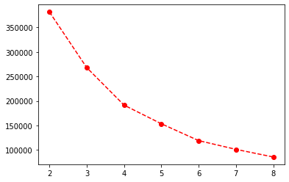

Out[ ]:

In [ ]:

mb **=** pd**.**Series(model**.**labels_)

KMeans(n_clusters=4)

In [ ]:

df['Cluster'] **=** mb

|  |  |  |  |  |  |  |  |  |  |
| --- | --- | --- | --- | --- | --- | --- | --- | --- | --- |
| In | [ | ]: | df | | | | | | |
| Out[ | | ]: |  | **CustomerID** | **Gender** | **Age** | **Annual Income (k$)** | **Spending Score (1-100)** | **Cluster** |
|  | |  | **0** | 1 | 1 | 19 | 15.00 | 39 | 0 |
|  | |  | **1** | 2 | 1 | 21 | 15.00 | 81 | 0 |
|  | |  | **2** | 3 | 0 | 20 | 16.00 | 6 | 0 |
|  | |  | **3** | 4 | 0 | 23 | 16.00 | 77 | 0 |
|  | |  | **4** | 5 | 0 | 31 | 17.00 | 40 | 0 |
|  | |  | **...** | ... | ... | ... | ... | ... | ... |
|  | |  | **195** | 196 | 0 | 35 | 120.00 | 79 | 1 |
|  | |  | **196** | 197 | 0 | 45 | 126.00 | 28 | 3 |
|  | |  | **197** | 198 | 1 | 32 | 126.00 | 74 | 1 |
|  | |  | **198** | 199 | 1 | 32 | 60.55 | 18 | 3 |
|  | |  | **199** | 200 | 1 | 30 | 60.55 | 83 | 1 |

200 rows × 6 columns